**DIAMOND PRICE ANALYSIS**

**Relationship between Diamond Weight and its Price**

[NAME]

[DEPARTMET, UNIVERSITY]

[COURSE CODE: COURSE NAME]

[PROFESSOR NAME]

[ASSIGNMENT DUE DATE]

**DIAMOND PRICE ANALYSIS**

**Relationship between Diamond Weight and its Price**

1. Compute a Pearson Correlation and linear regression to investigate relationship between a diamond’s weight and its price. From the output, identify the following:
2. Slope associated with the predictor variable?

*11598.88*

1. Constant for the regression equation?

*-2298.36*

1. Mean weight and price of the diamond?

|  |  |  |  |  |  |
| --- | --- | --- | --- | --- | --- |
| **Descriptive Statistics** | | | | | |
|  | N | Minimum | Maximum | Mean | Std. Deviation |
| WEIGHT | 308 | .18 | 1.10 | .6309 | .27718 |
| PRICE | 308 | 638 | 16008 | 5019.48 | 3403.116 |
| Valid N (listwise) | 308 |  |  |  |  |

*Mean weight = 0.63 carats, Mean price = $5,019.48*

1. Correlation between weight and diamond. Is the correlation significant?

*Correlation coefficient (r): 0.945.*

*The p-value is extremely small 3.04 × 10⁻¹⁵⁰ (< 0.001), meaning this correlation is statistically significant.*

1. Write a regression equation?

*Price= −2298.36+11598.88×Weight*

2. Also create a scatterplot. Plot the line of best fit (regression line) on the graph. What does the scatterplot indicate regarding the predictability of the dependent variable (price)?

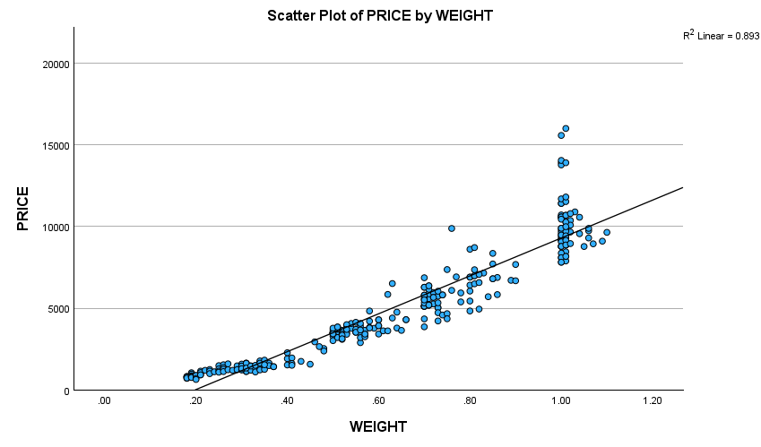

*Strong Positive Linear Relationship exists: The points formed are tight, upward-sloping cluster around the regression line suggesting that as weight increases, price also increases almost proportionally.*

*High Predictability: Given that most data points lie close to the line of best fit, hence low dispersion, meaning weight is a strong predictor of price.*

3. Is the price significantly related to the diamond’s weight? Interpret the results of the regression analysis to answer the question.

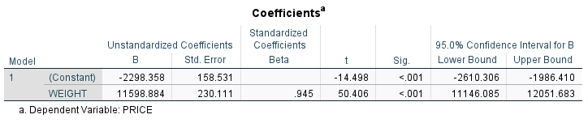

*p-value for WEIGHT < .001; This suggests that weight of a diamond is highly statistically significant in predicting price.*

|  |  |  |  |  |
| --- | --- | --- | --- | --- |
| **Model Summaryb** | | | | |
| Model | R | R Square | Adjusted R Square | Std. Error of the Estimate |
| 1 | .945a | .893 | .892 | 1117.564 |
| a. Predictors: (Constant), WEIGHT | | | | |
| b. Dependent Variable: PRICE | | | | |

*R-squared = 0.893; This suggests that, close to 89.3% of the variation in diamond price is explained by its weight.*

|  |  |  |  |  |  |  |
| --- | --- | --- | --- | --- | --- | --- |
|  | | | | | | |
| **ANOVA**  Model | | Sum of Squares | df | Mean Square | F | Sig. |
| 1 | Regression | 3173248722.467 | 1 | 3173248722.467 | 2540.734 | <.001b |
| Residual | 382178624.452 | 306 | 1248949.753 |  |  |
| Total | 3555427346.919 | 307 |  |  |  |
| a. Dependent Variable: PRICE | | | | | | |
| b. Predictors: (Constant), WEIGHT | | | | | | |

*F-statistic = 2540.7and p < .00; Hence the model as a whole is statistically significant.*

Conclusion: Yes, price is significantly related to a diamond's weight. The regression model is strong, and weight explains a major portion of the variation in price.

**RESULT OF THE ANALYSIS.**

The purpose of this study was to explore the relationship between a diamond’s weight and price. A Pearson correlation was conducted to examine the relationship between a diamond’s weight and its price. The results indicated a strong, positive correlation, (*r*) = .945, *p* < .001, this indicates that as the weight of a diamond increases, its price also tends to increase.

A linear regression analysis was performed to predict diamond price based on carat. The regression model was statistically significant, *F* = 2541.00, *p* < .001, and explained approximately 89.3% of the variance in diamond price (*R²* = .893, Adjusted *R²* = .892). The regression equation was:

Price=−2298.36+11598.88×Weight

The unstandardized coefficient for weight was significant, *B* = 11,598.88, *t* = 50.41, *p* < .001, indicating that for each additional weight, the price of a diamond increases by approximately $11,599. The constant was also significant, *B* = -2298.36, *t* = -14.50, *p* < .001.

Furthermore, the scatterplot visually confirms that **diamond weight is highly predictive of price**, making it a reliable variable for modeling and forecasting diamond values. The close fit of the data points to the regression line further reinforces the **accuracy and strength** of the linear relationship.

These findings thereby confirmed that diamond weight is a significant and strong predictor of price, and the predictive model fits the data very well.

**References**

Cohen, J., Cohen, P., West, S. G., & Aiken, L. S. (2003). *Applied multiple regression/correlation analysis for the behavioral sciences* (3rd ed.). Routledge.

Field, A. (2018). Discovering statistics using IBM SPSS statistics (5th ed.). SAGE Publications Ltd.  
<https://us.sagepub.com/en-us/nam/discovering-statistics-using-ibm-spss-statistics/book257672>